**Module (JAVASCRIPT BASIC & DOM) – 4**

**(Basic logic Question)**

1. What is JavaScript. How to use it?

Ans: JavaScript is a versatile programming language primarily used for adding interactivity and dynamic behavior to web pages. It's commonly used alongside HTML and CSS to create interactive features, animations, and dynamic content on websites.

Here's a brief overview of how to use JavaScript:

1. Embedding JavaScript: You can include JavaScript directly within HTML documents using <script> tags. For example:

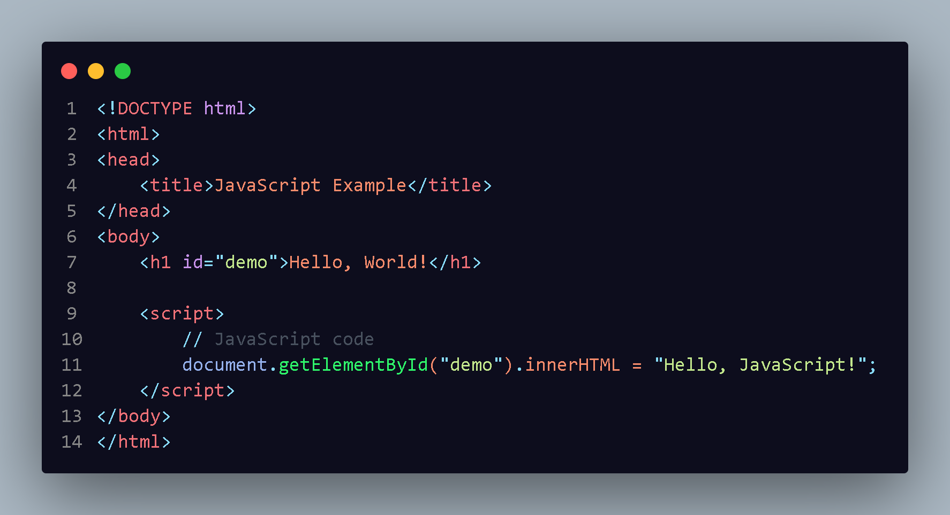

1. External JavaScript Files: You can also link to external JavaScript files using the <script> tag's src attribute. For example:

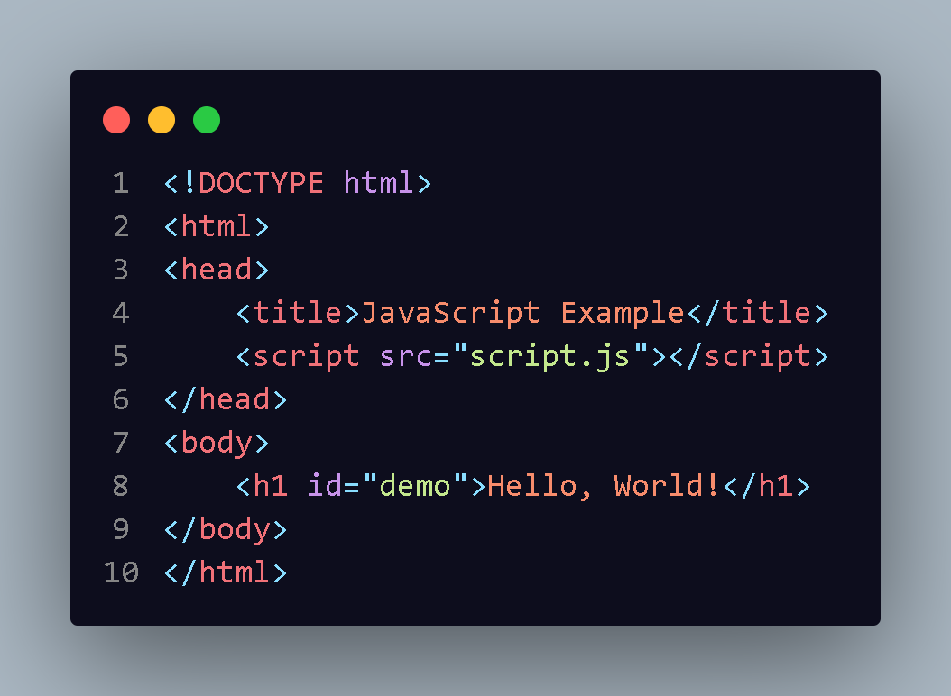

And in the script.js file

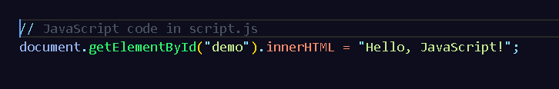

Event Handling: JavaScript is commonly used to handle events such as mouse clicks, keyboard inputs, and page loads. You can attach event listeners to HTML elements to respond to these events. For example:

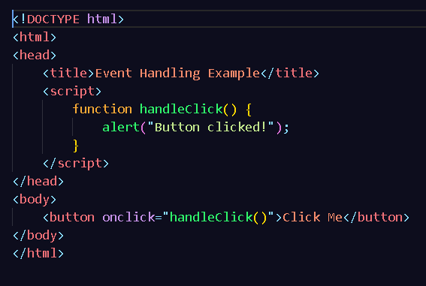

1. How many type of Variable in JavaScript?

Ans: - In JavaScript, there are primarily three types of variables:

var: var was traditionally used for variable declaration in JavaScript. Variables declared with var are function-scoped or globally-scoped, depending on whether they are declared inside or outside of a function, respectively.

let: Introduced in ECMAScript 2015 (ES6), let allows you to declare block-scoped variables. Variables declared with let are limited to the block

const: Also introduced in ECMAScript 2015 (ES6), const allows you to declare variables whose values are constant and cannot be reassigned. It behaves similarly to let in terms of block-scoping but prohibits reassignment of the variable after initialization.

1. Define a Data Types in js?

Ans: - In JavaScript, data types represent the kinds of values that can be used and manipulated in a program. JavaScript has primitive data types and complex data types.

Primitive Data Types:

Number: Represents numeric values. It can be integers or floating-point numbers.

String: Represents textual data, enclosed within single (''), double ("") or backtick (``) quotes.

Boolean: Represents a logical value indicating true or false.

Undefined: Represents a variable that has been declared but has not been assigned a value.

Null: Represents the intentional absence of any object value.

Symbol: Introduced in ECMAScript 2015 (ES6), represents unique identifiers.

BigInt: Introduced in ECMAScript 2020, represents integers of arbitrary precision.

Complex Data Types:

Object: Represents a collection of key-value pairs where values can be of any data type, including other objects, functions, and arrays.

Array: Represents a list-like collection of elements, which can be of any data type, accessed by numeric indices.

Function: Represents reusable blocks of code that can be called with different arguments.

Date: Represents dates and times.

RegExp: Represents regular expressions for pattern matching.

Here's a brief example showcasing some of these data types

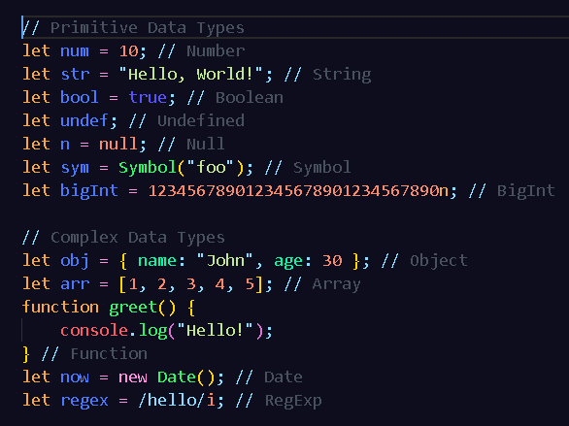

**4. Write a mul Function Which will Work Properly When invoked With Following Syntax.**

**Ans :-**

Let's create a simple multiplication function called `mul` that can be invoked in various ways:

```

javascript

function mul() {

// Check the number of arguments

const args = Array.from(arguments);

if (args.length === 0) {

// If no arguments are provided, return an error message

return "Error: No arguments provided. Please provide at least two numbers.";

} else if (args.length === 1) {

// If only one argument is provided, return the argument itself

return args[0];

} else {

// If multiple arguments are provided, multiply them together

return args.reduce((product, num) => product * num, 1);

}

}

// Examples of invoking the mul function

console.log(mul()); // Error: No arguments provided.

console.log(mul(5)); // 5 (returns the single argument)

console.log(mul(2, 3, 4)); // 24 (multiplies all arguments)

console.log(mul(1, 2, 3, 4, 5)); // 120 (multiplies all arguments)

```

This `mul` function checks the number of arguments passed to it and behaves accordingly. It returns an error message if no arguments are provided, returns the single argument if only one is provided, and multiplies all the arguments together if more than one is provided.

5. What the deference between undefined and undeclare in JavaScript?

Ans: - Undefined:

In JavaScript, "undefined" is a primitive data type and also a global variable.

When a variable is declared but not initialized, or when a function doesn't explicitly return a value, JavaScript assigns the value "undefined" to it by default. For example:

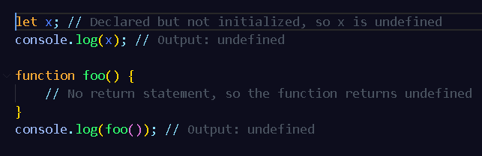

Undeclared:

An "undeclared" variable is one that has not been declared within the current scope using any of the variable declaration keywords (var, let, const).

Accessing an undeclared variable results in a ReferenceError.

For example

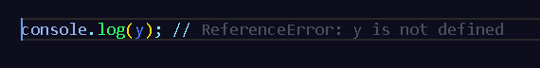

**QUESTION NO 6 TO 14 IN ATTACHED PRACTICAL- FOLDER**

**Q.15 What is the result of the expression (5 > 3 && 2 < 4)?**

**Ans :-**

The expression (5 > 3 && 2 < 4) is a logical AND operation. It checks whether both conditions are true:

- The condition 5 > 3 is true.

- The condition 2 < 4 is also true.

Since both conditions are true, the overall result of the expression is true.

**Q.16 What is the result of the expression (true && 1 && "hello")?**

**Ans:-**

In JavaScript, the logical AND operator (&&) evaluates expressions from left to right and stops as soon as it encounters a falsy value. If all values are truthy, it returns the last truthy value.

In the expression (true && 1 && "hello"):

- true is truthy.

- 1 is truthy.

- "hello" is truthy.

Since all values are truthy, the result of the expression is the last truthy value, which is "hello".

**Q.17 What is the result of the expression true && false || false && true?**

**Ans :-**

In JavaScript, the logical AND operator (&&) has higher precedence than the logical OR operator (||). The expression is evaluated from left to right.

Let's break down the expression true && false || false && true:

1. true && false evaluates to false.

2. false || false && true evaluates to false.

So, the overall result of the expression is false.

**QUESTION NO 18 TO 29 IN ATTACHED PRACTICAL- FOLDER**

**CONDITIONAL LOOPING QUESTIONS**

**Q.30 What are the looping structures in JavaScript? Any one Example?**

**ANS :-**

In JavaScript, there are several looping structures commonly used to execute a block of code repeatedly:

1. for loop: This loop executes a block of code a specified number of times.

Example:

javascript

for (let i = 0; i < 5; i++) {

console.log(i);

}

This loop will log the numbers 0 through 4 to the console.

2. while loop: This loop executes a block of code as long as a specified condition evaluates to true.

Example:

javascript

let i = 0;

while (i < 5) {

console.log(i);

i++;

}

This loop will also log the numbers 0 through 4 to the console.

3. do...while loop: This loop is similar to the while loop, but it will always execute the block of code at least once before checking if the condition is true.

Example:

javascript

let i = 0;

do {

console.log(i);

i++;

} while (i < 5);

This loop will log the numbers 0 through 4 to the console, similar to the previous examples.

These are the basic looping structures in JavaScript, each serving different purposes depending on the specific requirements of your code.

**Q.31 Write a print 972 to 897 using for loop in JS?**

**ANS:-**

To print numbers from 972 to 897 using a for loop in JavaScript, you can start the loop from 972 and decrement the loop variable until it reaches 897. Here's how you can do it:

javascript

for (let i = 972; i >= 897; i--) {

console.log(i);

}

This loop will start from 972, decrementing by 1 in each iteration, and will continue until it reaches 897, inclusive. It will print each number from 972 down to 897 on separate lines in the console.

**Q.32 Write to print factorial of given number?**

**ANS :**

javascript

function factorial(n) {

if (n === 0 || n === 1) {

return 1;

} else {

let result = 1;

for (let i = 2; i <= n; i++) {

result *= i;

}

return result;

}

}

// Example usage:

console.log(factorial(5)); // Output: 120

**Q.33 Write to print Fibonacci series up to given numbers?**

**ANS:**

javascript

function fibonacciSeries(limit) {

let fibArray = [0, 1];

while (fibArray[fibArray.length - 1] + fibArray[fibArray.length - 2] <= limit) {

fibArray.push(fibArray[fibArray.length - 1] + fibArray[fibArray.length - 2]);

}

return fibArray;

}

// Example usage:

const limit = 50;

const fibonacci = fibonacciSeries(limit);

console.log("Fibonacci series up to", limit, ":", fibonacci.join(', '));

**Q.34 Write to print number in reverse order e.g.: number = 64728 ---> reverse =82746 in JS?**

**ANS:**

javascript

function reverseNumber(number) {

const reversedNumber = parseInt(number.toString().split('').reverse().join(''));

return reversedNumber;

}

// Example usage:

const number = 64728;

const reversed = reverseNumber(number);

console.log("Original number:", number);

console.log("Reversed number:", reversed);

**Q.35 Write a program make a summation of given number (E.g., 1523 Ans: - 11) in JS?**

**ANS:**

javascript

function digitSum(number) {

let sum = 0;

const numStr = number.toString();

for (let i = 0; i < numStr.length; i++) {

sum += parseInt(numStr[i]);

}

return sum;

}

// Example usage:

const number = 1523;

const sum = digitSum(number);

console.log("Summation of digits of", number, "is:", sum);

**Q.36 Write a program you have to make a summation of first and last Digit. (E.g., 1234 Ans: - 5) in JS?**

**ANS:**

javascript

function sumFirstAndLastDigit(number) {

const numStr = number.toString();

const firstDigit = parseInt(numStr[0]);

const lastDigit = parseInt(numStr[numStr.length - 1]);

return firstDigit + lastDigit;

}

// Example usage:

const number = 1234;

const sum = sumFirstAndLastDigit(number);

console.log("Summation of the first and last digits of", number, "is:", sum);

**QUESTION NO 37 TO 39 ARE IN ATTACH PRACTICAL- FILE**

**Array and object Question**

**QUESTION NO 40 TO 46 ARE IN ATTACH PRACTICAL- FILE**

**Q.47 What is the drawback of declaring methods directly in JavaScript objects?**

**Ans:**

One drawback of declaring methods directly in JavaScript objects is that it can lead to code duplication and increased memory consumption, especially if multiple instances of the object are created.

When methods are declared directly within an object, each instance of that object will have its own copy of those methods. This means that if you have multiple instances of the same object, each instance will consume memory to store its own copy of the methods, even though the logic of those methods is identical across all instances.

This can become inefficient, especially in scenarios where memory usage is a concern, such as in memory-intensive applications or applications running on devices with limited resources.

To mitigate this drawback, you can use prototypes in JavaScript to define methods for object constructors. By defining methods on the prototype, all instances of the object share the same copy of those methods, reducing memory consumption and eliminating code duplication.

**QUESTION NO 48 AND 49 ARE IN ATTACH PRACTICAL- FILE**

**Q.50 What is the drawback of declaring methods directly in JavaScript objects?**

**ANS:**

One drawback of declaring methods directly within JavaScript objects, especially when creating multiple instances of those objects, is that it can lead to increased memory consumption and reduced performance.

When methods are defined directly within an object, each instance of that object will have its own copy of those methods. This means that memory will be allocated for each instance to store the method definitions, even though the logic of those methods is identical across all instances.

Additionally, if you modify the method of one instance, it does not affect the method of other instances because each instance has its own separate copy of the method. This can lead to code duplication and maintenance issues if you need to update the method logic for all instances.

To mitigate these drawbacks, you can use prototypes in JavaScript. By defining methods on the prototype of an object constructor, you ensure that all instances of that object share the same copy of those methods. This reduces memory consumption and eliminates code duplication, leading to better performance and easier maintenance.

**QUESTION NO 51 TO 56 IN ATTACHED PRACTICAL- FOLDER**

**Q.57 how many type of JS Event? How to use it?**

**Ans:**

JavaScript events are actions that occur as a result of user interactions or system events in a web page. There are various types of JavaScript events, including:

1. Mouse Events: These events occur when the user interacts with the mouse, such as clicking, hovering, or moving the mouse pointer.

- click: Occurs when the mouse button is clicked.

- dblclick: Occurs when the mouse button is double-clicked.

- mouseover: Occurs when the mouse pointer moves over an element.

- mouseout: Occurs when the mouse pointer moves out of an element.

- mousemove: Occurs when the mouse pointer is moved while it is over an element.

- mousedown: Occurs when the mouse button is pressed down on an element.

- mouseup: Occurs when the mouse button is released over an element.

2. Keyboard Events: These events occur when the user interacts with the keyboard.

- keydown: Occurs when a key is pressed down.

- keyup: Occurs when a key is released.

- keypress: Occurs when a key is pressed and released.

3. Form Events: These events occur when the user interacts with HTML form elements.

- submit: Occurs when a form is submitted.

- change: Occurs when the value of an input element changes (e.g., input field, select box).

- focus: Occurs when an element receives focus.

- blur: Occurs when an element loses focus.

4. Window Events: These events occur when the window or document is loaded, resized, or scrolled.

- load: Occurs when the window or document is loaded.

- resize: Occurs when the window is resized.

- scroll: Occurs when the document is scrolled.

5. Media Events: These events occur when media elements (such as <audio> or <video>) are played, paused, or ended.

- play: Occurs when the media playback starts.

- pause: Occurs when the media playback is paused.

- ended: Occurs when the media playback has ended.

You can use JavaScript event handlers to respond to these events. Event handlers are functions that are executed when an event occurs. You can attach event handlers to HTML elements using the addEventListener() method, or directly in HTML attributes. Here's an example of attaching an event handler using addEventListener():

javascript

// Get the element

var element = document.getElementById('myElement');

// Attach an event handler for the click event

element.addEventListener('click', function(event) {

// Handle the click event

console.log('Element clicked');

});

Alternatively, you can directly specify event handlers in HTML attributes like this:

html

<button onclick="handleClick()">Click me</button>

In this case, the handleClick() function will be called when the button is clicked.

**Q.59 What is Bom vs Dom in JS?**

**Ans:**

BOM (Browser Object Model) and DOM (Document Object Model) are two important concepts in JavaScript related to manipulating web pages and interacting with the browser environment. Here's a brief overview of each:

1. DOM (Document Object Model):

- The DOM represents the structure of an HTML document as a tree-like structure, where each node represents an element, attribute, or text in the document.

- It provides a way for JavaScript to access, manipulate, and update the content and structure of a web page dynamically.

- With the DOM, you can traverse the document tree, select specific elements, modify their content or attributes, add or remove elements, and handle events.

- The DOM is standardized by the World Wide Web Consortium (W3C), and it's supported by all modern web browsers.

2. BOM (Browser Object Model):

- The BOM represents the browser itself as an object, providing access to browser-specific features and functionalities.

- It includes objects such as window, document, navigator, location, history, screen, etc., which allow JavaScript to interact with various aspects of the browser and the user's environment.

- Unlike the DOM, which deals with the structure and content of web pages, the BOM deals with browser-related tasks such as controlling browser behavior, managing windows and frames, handling cookies, manipulating the browser's history, and accessing information about the user's system and environment.

- The BOM is not standardized by any official organization, and its features may vary between different browsers. As a result, developers often need to write browser-specific code or use feature detection to ensure cross-browser compatibility.

In summary, while the DOM provides a standardized way to interact with the structure and content of HTML documents, the BOM provides browser-specific functionalities and allows JavaScript to interact with the browser environment beyond just the document.

**Q.60 Array vs object defences in JS?**

**Ans:**

In JavaScript, both arrays and objects are commonly used data structures, but they serve different purposes and have distinct characteristics. Here's a comparison of arrays and objects in terms of their usage and characteristics:

1. Arrays:

- Arrays are ordered collections of values, typically used when you have a list of items that need to be accessed by their index.

- They can contain elements of different data types, including numbers, strings, objects, or even other arrays.

- Arrays have numerical indices, starting from 0, which allow for fast random access to elements.

- You can use various built-in array methods for manipulating and iterating over arrays, such as push(), pop(), splice(), forEach(), map(), filter(), etc.

- Arrays are useful for storing lists of related items, such as a list of names, numbers, or objects.

2. Objects:

- Objects are collections of key-value pairs, where each key is a unique string (or symbol) and each value can be of any data type.

- They are typically used to represent entities or complex data structures with named properties.

- Objects allow for easy access to values using their keys (property names), rather than numerical indices.

- You can use dot notation (object.property) or bracket notation (object['property']) to access or modify properties of an object.

- Objects can contain methods (functions) as values, allowing for encapsulation of behavior related to the object.

- They are commonly used for representing real-world entities, such as users, products, or any other structured data.

In terms of defense, both arrays and objects can have certain vulnerabilities, such as:

- Access Control: It's important to control access to properties or elements in both arrays and objects, especially in shared or public code. Exposing sensitive information or allowing unauthorized modifications can lead to security risks.

- Input Validation: Always validate input data when working with arrays or objects, especially when dealing with data from external sources (such as user input or API responses). Failure to validate input can lead to vulnerabilities like injection attacks or unexpected behavior.

- Data Integrity: Ensure data integrity by validating and sanitizing data before performing operations on arrays or objects. This helps prevent errors, inconsistencies, or unexpected behavior in your code.

In summary, while arrays and objects are versatile and powerful data structures in JavaScript, it's important to implement proper defensive practices to ensure the security and reliability of your code. This includes controlling access, validating input, and maintaining data integrity.

javascript

const str = "Hello, world!";

const arr = str.split(','); // Split the string at commas

console.log(arr); // Output: ["Hello", " world!"]

**QUESTION NO 61 TO 66 ARE IN ATTACH PRACTICAL- FILE**

**• What is JavaScript?**

**Ans :-**

JavaScript is a versatile programming language primarily used for creating interactive effects within web browsers. It allows developers to add dynamic behavior to web pages, making them more engaging and responsive to user actions. JavaScript is a core technology of the World Wide Web alongside HTML and CSS. It is commonly employed for tasks such as form validation, creating animations, fetching data from servers asynchronously (AJAX), building web applications (including single-page applications), and much more. With the advent of server-side JavaScript platforms like Node.js, JavaScript can also be used for server-side programming, enabling developers to create full-stack applications using a single programming language.

**• What is the use of isNaN function?**

**Ans:-**

The isNaN() function in JavaScript is used to determine whether a value is NaN (Not-a-Number) or not. NaN is a special value representing the result of an invalid mathematical operation, such as dividing zero by zero or attempting to convert a non-numeric string into a number.

The isNaN() function takes a single argument and returns true if the argument is NaN, and false otherwise. If the argument passed to isNaN() is not already of the number type, it is first converted to a number before being evaluated.

Here's an example:

javascript

isNaN(NaN); // true

isNaN(123); // false

isNaN('Hello'); // true, because 'Hello' cannot be converted to a number

isNaN('123'); // false, because '123' can be converted to the number 123

It's important to note that isNaN() may produce unexpected results when dealing with non-numeric strings. In such cases, it's often better to use other methods like Number.isNaN() introduced in ES6, which doesn't perform type coercion and only returns true if the provided value is exactly NaN.

**• What is negative Infinity?**

**Ans:-**

Negative Infinity, denoted as -Infinity, is a special value in JavaScript representing the lowest possible numeric value. It is used to represent a value that is smaller than any other numeric value, including negative numbers.

Negative Infinity typically arises as a result of mathematical operations that lead to a value that is smaller than the minimum representable value in JavaScript, or when dividing a negative number by zero.

For example:

javascript

console.log(Number.NEGATIVE_INFINITY); // -Infinity

console.log(-1 / 0); // -Infinity

console.log(Number.MAX_VALUE * -2); // -Infinity

Negative Infinity is often used to represent scenarios where a value tends toward negative infinity, such as in mathematical limits or when an algorithm reaches an extreme negative value. It's important to handle such cases carefully in code to avoid unexpected behavior or errors.

**• Which company developed JavaScript?**

**Ans:-**

JavaScript was developed by Netscape Communications Corporation, specifically by Brendan Eich. It was initially created in 1995 under the name "Mocha" but was later renamed "LiveScript" before finally being called JavaScript.

**• What are undeclared and undefined variables?**

**Ans:-**

Undeclared and undefined variables are two different concepts in JavaScript:

1. Undeclared Variables :- These are variables that have not been declared using the var, let, or const keywords before being used. If you try to use an undeclared variable, JavaScript will raise a ReferenceError. For example:

javascript

// This will throw a ReferenceError because x is undeclared

console.log(x);

2. Undefined Variables :- These are variables that have been declared but have not been assigned a value, or variables that have been explicitly assigned the value undefined. When you access such variables, they return the value undefined. For example:

javascript

let y;

console.log(y); // Output will be: undefined

let z = undefined;

console.log(z); // Output will also be: undefined

**• Write the code for adding new elements dynamically?**

**Ans:-**

html

<!DOCTYPE html>

<html lang="en">

<head>

<meta charset="UTF-8">

<meta name="viewport" content="width=device-width, initial-scale=1.0">

<title>Add Elements Dynamically</title>

</head>

<body>

<h2>Add Elements Dynamically</h2>

<div id="container">

<!-- Existing elements -->

<p>Existing Element 1</p>

<p>Existing Element 2</p>

</div>

<button onclick="addElement()">Add Element</button>

<script>

function addElement() {

// Create the HTML for the new element

var newElementHTML = "<p>New Element</p>";

// Get the container element

var container = document.getElementById("container");

// Concatenate the new HTML with the existing HTML of the container

container.innerHTML += newElementHTML;

}

</script>

</body>

</html>

In this example, the addElement() function creates the HTML string for the new element, then appends this HTML to the existing HTML content of the container element by directly modifying its innerHTML property. This approach achieves the same result as using appendChild() but without explicitly calling it.

**• What is the difference between ViewState and SessionState?**

**Ans:-**

ViewState and SessionState are both mechanisms used in ASP.NET for state management, but they serve different purposes and have different scopes:

1. ViewState :-

- ViewState is used to preserve the state of a page and its controls across postbacks. It stores the state of individual controls and is maintained on the client-side as a hidden field within the HTML output of the page.

- ViewState is specific to a single web page and is used to persist data between round-trips to the server and back to the client. It helps in maintaining the state of controls such as textboxes, checkboxes, dropdown lists, etc., so that their values remain consistent across postbacks.

- ViewState is lightweight and suitable for storing small amounts of data related to a single page.

2. SessionState :-

- SessionState, on the other hand, is used to store user-specific data across multiple requests and pages during a user session.

- It is stored on the server-side and can store larger amounts of data compared to ViewState.

- SessionState is accessible across multiple pages within the same web application and is often used to maintain user authentication, user preferences, shopping cart contents, etc.

- SessionState data is scoped to a user's session and can be accessed by any page within that session.

**• What is === operator?**

**Ans :-**

The === operator in JavaScript is known as the "strict equality operator." It is used to compare two values for equality without performing type coercion. This means that both the value and the type of the operands must be the same for the === operator to return true.

Here's how it works:

- If the operands are of the same type and have the same value, === returns true.

- If the operands are of different types or have different values, === returns false.

For example:

javascript

5 === 5; // true, both the value and type are the same

5 === '5'; // false, different types (number vs. string)

0 === false; // false, different types and values

In contrast to the === operator, the == operator performs type coercion before comparing the values. This means that if the operands are of different types, JavaScript will attempt to convert them to a common type before making the comparison. This can sometimes lead to unexpected results.

For example, 0 == false evaluates to true because JavaScript converts false to 0 before performing the comparison. However, 0 === false evaluates to false because they are of different types.

Using === is generally recommended for comparisons in JavaScript because it avoids the potential pitfalls of type coercion and leads to more predictable behavior.

**• How can the style/class of an element be changed?**

**Ans:-**

You can change the style or class of an HTML element using JavaScript. Here's how you can do it:

1. Changing Style :-

You can change the CSS style of an element directly by modifying its style property. This property allows you to manipulate individual CSS properties of an element. For example:

javascript

// Get the element by its ID

var element = document.getElementById("myElement");

// Change its background color

element.style.backgroundColor = "blue";

// Change its font size

element.style.fontSize = "20px";

2. Changing Class :-

You can also change the class of an element by modifying its className or classList property. The className property replaces the entire class attribute of the element, while the classList property provides more flexibility for adding, removing, and toggling individual classes. For example:

javascript

// Get the element by its ID

var element = document.getElementById("myElement");

// Change its class using className

element.className = "newClass";

// Change its class using classList (add, remove, toggle)

element.classList.add("newClass");

element.classList.remove("oldClass");

element.classList.toggle("active");

Using classList is generally preferred because it provides more convenient methods for manipulating classes and avoids common issues with directly manipulating the className property, such as accidentally overriding existing classes.

By using JavaScript to manipulate styles and classes dynamically, you can create interactive and responsive web pages that adapt to user actions and events.

**• How to read and write a file using JavaScript?**

**Ans :-**

In a web browser environment, JavaScript alone cannot directly read or write files on a user's system for security reasons. However, it can interact with files indirectly through user actions such as file input in HTML forms or by utilizing Web APIs like the File API or the FileReader API.

Here's a basic example of reading a file using JavaScript with the FileReader API:

html

<!DOCTYPE html>

<html lang="en">

<head>

<meta charset="UTF-8">

<meta name="viewport" content="width=device-width, initial-scale=1.0">

<title>File Reader Example</title>

</head>

<body>

<input type="file" id="fileInput">

<button onclick="readFile()">Read File</button>

<script>

function readFile() {

var fileInput = document.getElementById('fileInput');

var file = fileInput.files[0];

var reader = new FileReader();

reader.onload = function(event) {

var contents = event.target.result;

console.log(contents); // Display the contents of the file

};

reader.onerror = function(event) {

console.error("File could not be read! Code " + event.target.error.code);

};

reader.readAsText(file);

}

</script>

</body>

</html>

This code creates an input element of type "file" and a button. When the button is clicked, it triggers the readFile() function. Inside this function, the FileReader API is used to read the contents of the selected file. The readAsText() method is used to read the file as a text file. Once the file is successfully read, the onload event is triggered, and the contents of the file are logged to the console.

For writing files, JavaScript in a web browser environment does not have direct access to write files to the user's system due to security restrictions. However, you can generate downloadable files by creating data URLs or using Blob objects. Alternatively, in server-side environments like Node.js, you can use the built-in File System module to read and write files.

**• What are all the looping structures in JavaScript?**

**Ans :-**

JavaScript offers several looping structures to execute a block of code repeatedly. The main looping structures in JavaScript are:

1. for loop: The for loop is used to execute a block of code a specified number of times. It consists of three parts: initialization, condition, and iteration. Syntax:

javascript

for (initialization; condition; iteration) {

// code block to be executed

}

2. while loop: The while loop executes a block of code as long as a specified condition is true. Syntax:

javascript

while (condition) {

// code block to be executed

}

3. do...while loop: Similar to the while loop, the do...while loop executes a block of code once, and then repeats the loop as long as a specified condition is true. Syntax:

javascript

do {

// code block to be executed

} while (condition);

4. for...in loop: The for...in loop iterates over the properties of an object. Syntax:

javascript

for (variable in object) {

// code block to be executed

}

5. for...of loop: The for...of loop is used to iterate over iterable objects such as arrays, strings, maps, sets, etc. Syntax:

javascript

for (variable of iterable) {

// code block to be executed

}

These looping structures provide different ways to iterate over data or execute a block of code repeatedly, allowing developers to choose the most appropriate one based on the requirements of their code.

**• How can you convert the string of any base to an integer in JavaScript?**

**Ans:-**

To convert a string representation of a number in any base to an integer in JavaScript, you can use the parseInt() function along with specifying the radix (base) as the second argument. The radix indicates the base of the numeral system used in the string. Here's how you can do it:

javascript

// Convert a binary string to an integer

var binaryString = "1010";

var integerValue = parseInt(binaryString, 2);

console.log(integerValue); // Output: 10

// Convert a hexadecimal string to an integer

var hexString = "1A";

var integerValue = parseInt(hexString, 16);

console.log(integerValue); // Output: 26

// Convert an octal string to an integer

var octalString = "23";

var integerValue = parseInt(octalString, 8);

console.log(integerValue); // Output: 19

In each case, parseInt() takes the string representation of a number (binaryString, hexString, octalString) and converts it to an integer based on the specified radix (2, 16, 8 for binary, hexadecimal, and octal respectively). The function returns the integer value.

**• What is the function of the delete operator?**

**Ans :-**

The delete operator in JavaScript is used to remove a property from an object. It allows you to delete both own properties of an object and properties inherited from its prototype chain. Here's how the delete operator works:

javascript

var obj = { a: 1, b: 2, c: 3 };

// Deleting a property

delete obj.b;

console.log(obj); // Output: { a: 1, c: 3 }

In this example, the property b is removed from the object obj using the delete operator. After deletion, the object only contains the properties a and c.

It's important to note that delete only affects the properties of an object, not the object itself. It returns true if the operation is successful (i.e., if the property is successfully deleted), and false otherwise. However, there are some limitations to using delete:

- delete only works on properties with configurable attributes. Non-configurable properties (those created using Object.defineProperty() with configurable: false) cannot be deleted.

- delete does not remove properties that are declared with var, let, or const keywords or function declarations.

- delete does not affect variables or functions declared in the global scope or variables declared with var within functions.

The delete operator is most commonly used when you need to dynamically remove properties from an object, such as when manipulating complex data structures or managing object properties at runtime.

**• What are all the types of Pop up boxes available in JavaScript?**

**Ans:-**

JavaScript provides several types of popup boxes for displaying messages or prompting user input. The main types of popup boxes are:

1. Alert Box: Displays a message to the user with an "OK" button. It's used to provide information or alerts.

javascript

alert("This is an alert message!");

2. Confirm Box: Displays a message to the user with "OK" and "Cancel" buttons. It's used to confirm or cancel an action.

javascript

var result = confirm("Are you sure you want to proceed?");

if (result === true) {

// User clicked OK

} else {

// User clicked Cancel

}

3. Prompt Box: Displays a message to the user with an input field where they can enter data. It's used to prompt the user for input.

javascript

var userInput = prompt("Please enter your name:", "John Doe");

if (userInput !== null) {

// User entered something

} else {

// User clicked Cancel

}

**• What is the use of Void (0)?**

**Ans:-**

In JavaScript, void(0) is a special expression that evaluates to undefined. It is often used in the context of anchor (<a>) elements in HTML to prevent the browser from navigating to a new page when the anchor is clicked without having to specify an actual URL.

Here's how it's typically used:

html

<a href="javascript:void(0)">Click me</a>

When a user clicks on the "Click me" link, the browser will execute the JavaScript expression void(0), which returns undefined. Since there is no valid URL associated with the anchor, the browser stays on the same page without navigating anywhere.

The use of void(0) is a common practice in situations where you want to attach JavaScript behavior to an anchor element without causing any navigation. However, it's worth noting that modern JavaScript practices tend to favor more semantic and accessible solutions, such as using event listeners or leveraging the href attribute with a meaningful URL or # for anchor links that trigger JavaScript actions.

**• How can a page be forced to load another page in JavaScript?**

**Ans :-**

In JavaScript, you can force a page to load another page by setting the window.location property to the URL of the desired page. This triggers a navigation to the specified URL, effectively loading a new page. Here's how you can do it:

javascript

window.location = "https://www.example.com/newpage.html";

When this line of code is executed, the browser will navigate to the URL specified in the window.location assignment, causing the current page to be unloaded and the new page to be loaded.

You can also use other methods of the window.location object to perform different types of navigation, such as reloading the current page (window.location.reload()), navigating to the previous page in the browser's history (window.history.back()), or navigating to the next page in the browser's history (window.history.forward()).

It's important to note that forcing a page to load another page abruptly can disrupt the user experience and might be considered bad practice in certain contexts. Ensure that such navigation actions are clear and expected by users.

**• What are the disadvantages of using innerHTML in JavaScript?**

**Ans :-**

While the innerHTML property in JavaScript is convenient for manipulating the content of HTML elements, it also has some disadvantages:

1. Security Risks :- Using innerHTML can expose your application to cross-site scripting (XSS) attacks if the content being inserted contains untrusted or user-generated data. If this data includes malicious scripts, they can be executed within your page, leading to security vulnerabilities.

2. Performance Overhead :- Manipulating innerHTML often involves parsing and re-rendering the entire content of the targeted element, which can be inefficient for large or complex DOM structures. This can result in performance overhead, especially on mobile devices or older browsers.

3. Event Handler Removal :- When you set innerHTML to replace the content of an element, any event listeners attached to child elements will be lost. This requires re-attaching event listeners after updating the content, which can be cumbersome and error-prone.

4. Loss of References :- If the content being replaced or inserted via innerHTML includes elements with JavaScript event handlers or references, those references may be lost or become invalid after the content is replaced, leading to unexpected behavior or memory leaks.

5. Non-Standard HTML Parsing :- While most modern browsers handle innerHTML consistently, there can be differences in how HTML is parsed and rendered across different browsers. This can lead to inconsistencies or unexpected behavior in edge cases.

To mitigate these disadvantages, consider using alternative methods for DOM manipulation, such as createElement, appendChild, insertBefore, or more advanced techniques like using virtual DOM libraries (e.g., React, Vue.js) or server-side templating engines (e.g., Handlebars, EJS) for building dynamic user interfaces. Additionally, always sanitize and validate any user-generated content before inserting it into the DOM to prevent XSS attacks.

**• Create password field with show hide functionalities**

**Ans:-**

You can create a password field with show/hide functionality using HTML, CSS, and JavaScript. Here's a simple example:

HTML:

html

<label for="password">Password:</label>

<input type="password" id="password" name="password">

<span id="togglePassword" onclick="togglePasswordVisibility()">Show</span>

CSS:

css

#togglePassword {

cursor: pointer;

color: blue;

text-decoration: underline;

}

JavaScript:

javascript

function togglePasswordVisibility() {

var passwordField = document.getElementById("password");

var toggleButton = document.getElementById("togglePassword");

if (passwordField.type === "password") {

passwordField.type = "text";

toggleButton.textContent = "Hide";

} else {

passwordField.type = "password";

toggleButton.textContent = "Show";

}

}

In this example, we have an HTML input field of type "password" for entering passwords. Next to it, we have a span element with the id "togglePassword" that acts as a button to toggle the password visibility. When the button is clicked, the togglePasswordVisibility() function is called, which toggles the type of the password field between "password" and "text" (to show or hide the password), and updates the text content of the button accordingly.

This provides a simple way for users to toggle the visibility of the password they are entering.